Using the debugger it seems like the function goes into the for loop 1 time too many

So for power of 2 it should only go into the loop once however because I starts at 1 it goes into the loop 2 times which results in it cubing the number instead of squaring. An easy solution would be to remove the <= and making it a <. This fixes this issues. However there is also the issue with negative numbers, this happens because of the usage of int8 which can only reach a maximum value of 128. To fix this a larger data type could be used like uint16 or int16.

This code results in

Which is now correct



Since we pull the input down its default value is 0 and the code for initializing is shown below

Use the same code from the joystick and now made some for the LED



Same program for joystick as last time

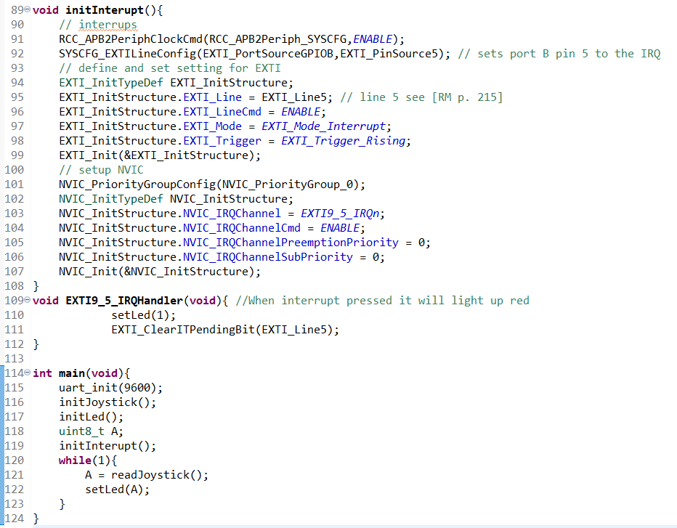

Made it so that when the center button is pressed the LED will light up red

Made it so that the led will blink every 1/100th of a second and then when the center is pressed it will turn off.